Student Council Motion Proposal

Your Policy Motion Title Goes Here:
Policy Number: | For SU Use Only |  | Policy Date | For SU Use Only
Policy Proposer: (Include name and student number) |  | Harry Lonsdale 15001561
Policy Seconder: (Include name and student number) |  | Andrew Aldis 15002519

Summary:
I would like to propose a motion for the creation of a wellbeing space for students and staff where they can relax and rest in quiet.

Student Council Notes the Following Facts:
- There is currently no real space at the University where students can go to relax in the day.
- There is a large stigma around mental health currently at the university.
- There is a small outdoor garden which is deemed as a place to relax but not a welcoming area.
- The University offers ‘fancy a cuppa?’ service but it is currently located in first point which has a busy footfall and not a great place to relax.
- CASE STUDY – UEA (University of East Anglia) has dedicated a room for students to relax and sleep if they are stressed. This room is dark and peaceful offering time to rest.

Student Council Holds the Viewpoint That:
- Students and staff have full on days and it is important that there is space for them to relax and re-energy themselves throughout the day rather than a busy canteen.
- Students and staff that commute to the university don’t have time to go home and relax in a comfortable space in-between lectures.
- When stressful deadlines come up and especially dissertation time, there is nowhere students can go to take their mind of things apart from used spaces.
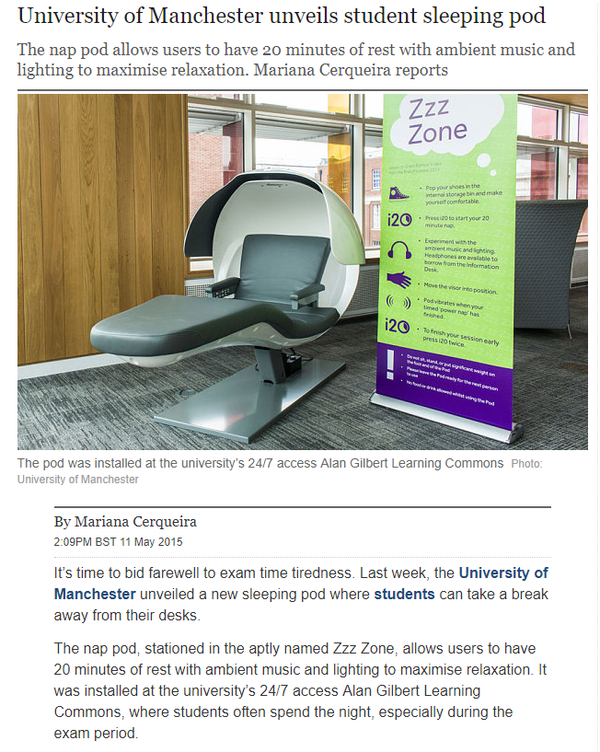

Student Council Resolves to Take the Following Action(s):
- To start talks with the University and Students Union to see how this matter could be approached.
- To think about where this could fit on ST Johns Campus for logistical reasons.
- Find out what students really want in order to relax if that be sensory or comfort for example.

