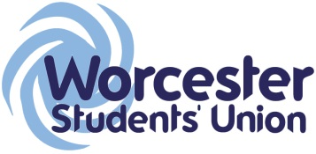
Executive Officer Report to Student Council
Officer Name / Role: Lewis Arnold- Vice President Education

Date of report: 22/10/15

What work have you been undertaking towards your objectives since the last meeting? Please limit this to 5 items.

- Recruitment of StARs & institute reps (complete).
- Planned the upcoming StAR training.
- Planned monthly forum between Ins reps & myself.
- SU @ home & SU on tour in order to interact with those students that are traditionally harder to engage (mature/city campus).

What progress have you made on actions you have been mandated by Student Council to carry out?

The position for foundation/Non degree student council rep was added to the by-elections.

List up to 5 other duties of note have you been carrying out within your role and state how has this been benefitting students?

- Prepared & submitted a report to SSWG regarding the UWSS: Qs relating to SU will now be included in the UWSS, similar to that in NSS (Q23). This will give the SU more feedback on students so that we can continue to enhance our services.
- Prepared a report for LTSEC, with a motion to ELECT, rather than select ins reps. This makes reps more accountable to students & gives them a formal mandate to act on students behalf.
- Discussed Worcester Weeks with UW staff & Wes in order to provide students with guidance & direction during the weeks, with the aim of making the weeks more enjoyable/beneficial.
- Attended University meetings to ensure that they are student centred and student opinion is voiced (LTSEC/ACADEMIC BOARD/SSWG/BOG/TB).
- Developed and promoted the SAP schemes so that students can work in partnership with staff and gain valuable employability skills.

What are the 5 key tasks you aim to get done before the next meeting?

- Successfully deliver the StAR training.
- Submit the motion to elect ins reps to LTSEC
- Begin planning my campaign to increase awareness of degree classification.
- Formal review the relationship between TLI & the SU.
- Address issues raised by ins reps at monthly forums at institute level meetings.

