Jack Buczynski
RaG report, November 2014
- Raised £80 for in Halloween bake sale
- Raised £10 at volunteer fair with our guess how many skittles are in this martini glass competition
- Raised £30 from a head shave
- Raised £160 plus for Children in need
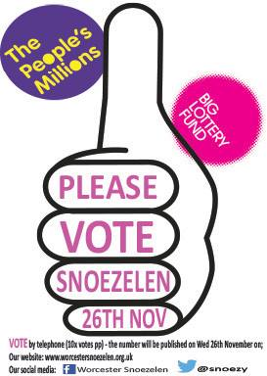
- Raised ____ in bucket collection on 22nd for our charities

Met Snoezelen with Wes – really impressed by the work they do their, give around 300 people a week a chance to have time in their very relaxing sensory rooms.
The Biggest help we are to them currently is to promote their campaign for them to get as many calls as possible in a competition, the prize being a large amount of money which will go towards the refurbishment of the centre.

Spoke to Headway – they would like us to host a Fashion night with the clothes from their shop in the New Year. Early stages – anyone fancy getting involved, feel free to let me know.
In talks with St. Richards and Worcester Rape and Sexual support clinic about fundraisers we can get involved with and help with.

RaG will be selling Krispy Kreme doughnuts, red ribbons and raising awareness of the cause on Worlds Aids Day. (1st December)
Santa’s Grotto for just before we break up for Christmas is in the pipeline.

