Council report
Turnitin
The university is looking to bring in the programme Turnitin across all courses. At the moment it is used sporadically and up until recently no university wide policy existed. For the coming academic year it will be highly recommended to all university staff that all assignments that are able to be submitted through Turnitin are. Then for the following academic year 2015-16 the policy will change slightly so that all assignments that can be submitted through Turnitin are done that way. This will obviously due to the online nature of the programme mean that this will see a vast improvement in the number of assignments that are submitted electronically.
Printer Credit
Last year I began the process of looking into gaining free printer credit for all students, with the University eventually deciding against the idea. However I was assured that this was something that could certainly be revisited this year due to the nature of the University's financial planning. The initial emails regarding this have been sent out to the relevant members of University staff.
StARs
At the time of this report being written there were over 200 StARs uploaded onto the University SOLE page. However we still rely heavily on staff uploading their courses StARs onto this or we have no idea who they are. In a positive development though regarding this, Course Leaders used to be the only people who could do this. The Pro Vice Chancellor Students is now sending out weekly emails to all University staff ‘naming and shaming’ courses which are yet to elect StARs or upload them onto SOLE.
Myself and the membership services manager at the Students Union have met in recent weeks with the some of the StAR co-ordinators to discuss the upcoming plans for training and the overall year ahead.
The main focus of the year ahead will be to engage and improve the quality of the StARs we have. We quite comfortably get 500 students taking up the role however the percentage of these that fully engage with the system is significantly lower than that. We will be encouraging as many StARs as possible to see the extra benefits they receive from engaging with the system, such as the accreditation scheme and the volunteering hours that they can record.
Wealso produced ‘sign up’ cards also that any student wishing to be considered for the role as StAR. These were to be filled in and given to the students course leader who then kept hold of them and kept the student informed regarding the election process.
StARs Training
This year’s training will take place during the University's first Worcester Week. With myself running the generic 'how to be a StAR' session aimed at first year StARs (however returning StARs are still able to attend if they wish). This year we will also run extra sessions for returning StARs with the aim of focusing on the Quality of StARs. See the table below for exact dates and times.
Also we have been in discussion with each of the Institutes to encourage them to run training sessions of their own to train up their own StARs. As each Institute works in different ways and as a Students Union we are not always aware of the differences.

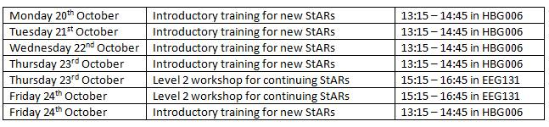
Hoodies and Wristbands
Also as another incentive I have managed to secure funding off the University to provide each StAR with a hoody with the StARs logo printed on the back so there fellow students know who their StARs are. To receive a hoody all the student has to do is register as a StAR on our online volunteering system and attend one of the training sessions put on by myself.
Alongside the hood the StARs will receive a wristband that will be colour co-ordnated to bring together the StARs system generic orange imagery and the purple volunteering theme.
Institute Representatives
Following the application deadline and interview process that followed we have been able to nearly complete our full set of Institute Reps for the year, with the only Institute still awaiting a full quota being that of Health and Society.
In the process of undertaking the interview process with Science and the Environment I was able to gain funding for them to undertake an extra Institute Rep for the year, bringing the total Reps for that Institute up to 3 from 2.

