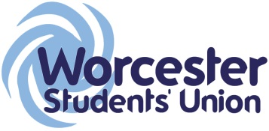
Executive Officer Report to Student Council
Officer Name / Role: Debbie Doyle – Mature Student Officer

Date of report: 20/11/15

What work have you been undertaking towards your objectives since the last meeting? Please limit this to 5 items.

- Recruit committee to help with role.
- Establish contact with Partner colleges.
- Make Contact with PTO’s in other universities.
- Create events for mature students in semester 1
- Devise strategy for. ‘Buddy’ mentor scheme

What progress have you made on actions you have been mandated by Student Council to carry out?

No mandated actions at the time of this report

List up to 5 other duties of note have you been carrying out within your role and state how has this been benefitting students?

- Created MSO skype and email account for contact with partner colleges, |this should enable a more f2f environment for MS students.
- Arranged visit along with President and VP education to Partner colleges. Meetings have been set in both Exeter and Roche to get feedback from students and to make contact with their MS StARs
- Making contact with Business school MS and to gain feedback on their requirements.

What are the 5 key tasks you aim to get done before the next meeting?

- To have involved International and Disabled students officers in collaborated event
- To have arranged both semester 1 events
- To have an approved strategy for ‘Buddy’ scheme to roll out for January 2106 intake.
- To have addressed any issues raised by partner college students prior to January meeting.
- To have events in progress for semester 2 for MS.

