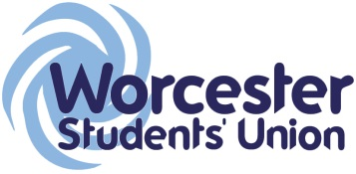
Executive Officer Report to Student Council
Officer Name / Role: Amy - RaG

Date of report: april 16

What work have you been undertaking towards your objectives since the last meeting? Please limit this to 5 items.

- 'The Paper Championships' is in the pipeline
- End of year halls collection (2/3 charities will take donations) planning

What progress have you made on actions you have been mandated by Student Council to carry out?

N/A

List up to 5 other duties of note have you been carrying out within your role and state how has this been benefitting students?

What are the 5 key tasks you aim to get done before the next meeting?

- Small bubble football advertising campaign
- Date & location for paper Champs set
- Promo material for paper champs done & started
- Logistics of collection day sorted
What, in particular, do you want to draw to Student Council’s attention? (This might include events/activities you’re planning, feedback from meetings you’ve attended or something you’d like Student Council to discuss or debate, for instance).

The paper championships will be a wednesday, and include different (top secret) challenges involving paper. Teams will compete in several catagories before a champion is found. Each stage will consist of building and testing

