Food Preparation Guidelines

Guidance for home-made or shop brought cake or biscuit stalls sales

The following only applies to those cakes or biscuits made at home
Buy your ingredients from a reputable supplier and make sure they are all well within their best before or use by dates.
- Always wash your hands before preparing food.
- Make sure that surfaces, bowls, utensils, and any other equipment is clean and sanitised
- Don't use raw eggs in anything that won't be thoroughly cooked, such as icing or mousse
- Keep cheesecakes and any cakes or desserts containing cream in the fridge
- Store cakes/biscuits in a clean, sealable container, away from raw foods, especially raw meat, and possible sources of allergies such as nuts
- Try to make the food as close to the event as possible, ideally no later than the day before the sale

The following applies to all cakes and biscuit sales before they arrive on site

- All items should have a clear list of ingredients available to view.
- If they are made at home you should record each ingredient and type them up on a sheet to be clearly displayed by each item on the day.
- If you have shop brought items you should retain the packaging to display the ingredients next to each item on the day. We do not recommend you type up a copy of a list of shop brought ingredients as you may inadvertently miss one out.

The following applies to all cake or biscuit stalls during the sale

- Transport cakes in a clean, sealable container
- Wash their hands as frequently as possible. Try to have someone separate from the serving of the cakes/biscuits to just handle money transactions as this is the primary source of contamination
- Do not sell or bring cheesecake and any cakes or desserts containing cream unless you will be storing them in a fridge/chiller
- When handling cakes use tongs or a cake slice instead of your hands
- If you have items for sale with nuts in as an ingredient or are selling items as gluten free ensure you use separate tongues or a cake slice to serve those items. Do not mix them up! This also applies to any other items you are promoting as being free of a specific allergen.

Allergens Deceleration
It is very important that you know exactly what is in your food. When cooking your food keep a written record of all the ingredients that are going into the product and look carefully to see if they have previously been in contact with allergens.

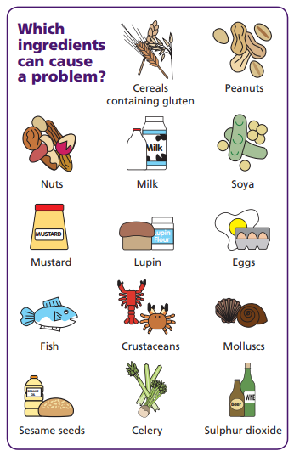
If you have not cooked the item- do not guess what allergens may be in it as this could cause harm to other people. You need to inform people if any food products you sell or provide contain any of the main 14 allergens as an ingredient.

You need to provide a clear ingredient list when displaying food for people to buy. If there is a possibility any of these 14 allergens could be in your food or come into contact with your food then you cannot allow someone with an allergen to purchase.

Controlling cross-contamination
There are different things you can do to prevent cross-contamination with allergens. These include:

- Having separate work surfaces, chopping boards and utensils for foods prepared free from one or several allergens and cleaning utensils before each usage, especially if they were used to prepare meals containing allergens.
- Storing ingredients and prepared foods separately in closed and labelled containers
- Keeping ingredients that contain allergens separate from other ingredients
- Washing hands thoroughly between preparing dishes with and without certain allergens

If you can’t avoid cross-contamination you always make those purchasing food items from you aware of this.

