Cake Sale Guidelines

Cake sales are often run as a way to raise money for charity. They are popular and when run correctly can be good fundraisers, but they aren’t always the answer. Cake sales do not always make money, when you take into account buying ingredients or ready-made cakes, it can instantly take at least £10 out of your profits. When you consider all the baking, organising, promoting and selling you have to do there are sometimes much better ways to raise money. Get in touch with the Students’ Union if you need help thinking up a new idea or consult the Fundraising Event Ideas Booklet.

If you still think that you would like to run a cake sale, try and think of ways that you could make it more efficient. It would be a good idea to target specific events or times of the day such as lunch time to ensure you attract a lot of customers. You also need to ensure that you think about your prices to ensure they are affordable for students but that you will make a good profit for charity. The more time you spend planning the more successful your event will be.

Always pop into the students’ Union or email the Student Engagement Coordinator to discuss your cake sales and other event ideas in more detail.

Guidelines
If you are baking and selling cakes you must comply with the following guidelines to ensure you are considering health and safety as well as hygiene. Before running your event, read all of these guidelines carefully.
- Always wash your hands before preparing food. You should not be wearing nail varnish, jewellery and your hair should be tied back.
- Before cooking clean all utensils, surfaces and equipment.
- Keep products in the fridge for as long as possible before selling them especially if they contain fresh produce e.g. cream.
- Do not put freshly baked items near to raw meat.
- Use the correct utensil to serve the food and consider serving on paper plates or napkins.
- Only use raw eggs in items that will be thoroughly cooked.
- You are required by law to create a list of allergens when selling food. Please ensure you fully aware of all the ingredients and possible allergens that your food contains. It could be helpful to keep this list on you to inform other people.
- If there are any allergens in your snacks they should be stored separately to other items.
- Inform the Students’ Union of all items that you are selling to ensure that they will allow this.
- Do not use meat of any kind without prior permission from the Students’ Union.

Remember, when selling food for charity it cannot be sold at a fixed price. You can only ask for a suggested donation. You can create price labels but it must be obvious that this is only a donation.

Allergens Deceleration
It is very important that you know exactly what is in your food. When cooking your food keep a written record of all the ingredients that are going into the product and look carefully to see if they have previously been in contact with allergens.

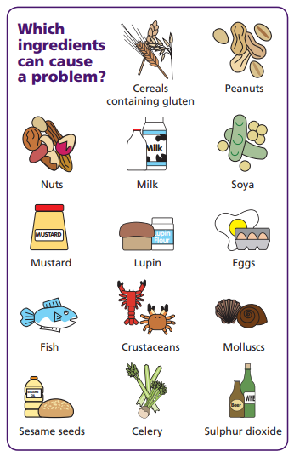
If you have not cooked the item- do not guess what allergens may be in it as this could cause harm to other people. You need to inform people if any food products you sell or provide contain any of the main 14 allergens as an ingredient.

You need to provide a clear ingredient list when displaying food for people to buy. If there is a possibility any of these 14 allergens could be in your food or come into contact with your food then you cannot allow someone with an allergen to purchase.

Controlling cross-contamination
There are different things you can do to prevent cross-contamination with allergens. These include:

- Having separate work surfaces, chopping boards and utensils for foods prepared free from one or several allergens and cleaning utensils before each usage, especially if they were used to prepare meals containing allergens.
- Storing ingredients and prepared foods separately in closed and labelled containers
- Keeping ingredients that contain allergens separate from other ingredients
- Washing hands thoroughly between preparing dishes with and without certain allergens

If you can’t avoid cross-contamination you always make those purchasing food items from you aware of this.

