



ACADEMIC PROCEDURES GUIDE

CONTENTS
- INTRODUCTION

- WHERE CAN I GET HELP ON CAMPUS?

- COMPLAINTS AND APPEALS

- MITIGATING CIRCUMSTANCES

- DISSERTATION EXTENSIONS

- WITHDRAWAL FROM STUDIES

- DISCIPLINARY PROCEDURES
Including Fitness to Practice
- ACADEMIC MISCONDUCT
(Plagiarism or Cheating)
- DEGREE CLASSIFICATION
- THE OFFICE OF THE INDEPENDENT ADJUDICATOR
INTRODUCTION
The Students’ Union Help and Advice Service has put together this guide to help students understand how to make sure their studies stay on track, and where to get support if things don’t go to plan.
If you have further questions, please get in touch with us at www.worcsu.com/helpandadvice.
We have a wealth of knowledge and experience and will either be able to offer the support you need or signpost you to someone who can help.
You don't need to be on campus to get advice. Telephone and MS Teams advice appointments are available alongside face-to-face.
This resource provides some initial guidance and is not intended to replace the full details or regulations and procedures.
The University has an extensive website which contains detailed information about every aspect of the University, its processes and procedures.
The Students' Union provides a free, independent, confidential, and impartial advice service to all students at the University of Worcester. This includes students studying at partner colleges.
Advice and support are offered to all students regardless of race, religion, gender, disability, or sexual orientation.




WHERE CAN I GET HELP ON CAMPUS?


ACADEMIC SUPPORT
On campus there are a number of different people who offer academic support, including:
Personal Academic Tutor (PAT) Course Leader/Lecturer
•
•
•
Program Advisers
Students’ Union Help & Advice Service Academic Liaison Librarians
•
•
Writers in Residence Course Reps Language Centre
•
•

EXTERNAL SUPPORT
GP and other NHS services Citizens Advice Bureau
•
•
National Debtline
•

NON-ACADEMIC SUPPORT

For comprehensive information around on campus support:
Visit: www.worcester.ac.uk/firstpoint
Email: firstpoint@worc.ac.uk
Call: 01905 542551
Who you chose to speak to regarding
non-academic support will depend on the type of problem you have.
Within the University there are many places to seek support and most services can be accessed from firstpoint:
Student Services
•
•
(including Money Advice, the Disability & Dyslexia Service, Careers, Counselling and Mental Health)
International Experience
•
University Community and Security Officers Accommodation
•

NON-ACADEMIC SUPPORT FROM THE STUDENTS’ UNION ADVICE SERVICE
The Students’ Union Advice Service can offer advice and support on a wide range of issues such as non-academic housing issues like contract checking and housemate issues as well as consumer problems.



COMPLAINTS AND APPEALS

ACADEMIC APPEALS

What is the difference between a complaint and an appeal?
An Academic Appeal is made to the Academic Registrar if there has been an administrative error in the conduct of an assessment, application of the regulations or some other irregularity relevant to an assessment.
Students cannot appeal on the grounds of disagreeing with academic judgement.
See the Office of the Independent Adjudicators (OIA) statement on Academic Judgement:
www.oiahe.org.uk/glossary.aspx

COMPLAINTS
A Complaint would be made in respect of a student’s experience at University including the relationship with administration, any services, departments, or discrimination issues.

PLACES TO GET ADVICE:
SU Advice Service | suadvice@worc.ac.uk
ﬁrstpoint | firstpoint@worc.ac.uk
Registry | complaintsandapeals@worc.ac.uk

WHAT CAN THE SU DO?
Our Advisors can:
Explain the complaints and appeals procedures (sometimes they’re hard to understand)
•
Advise you on how to structure an effective complaint
•
Read over your complaint or appeal and offer advice on improving it
•
Attend University meetings with you regarding your complaint
•
For more advice on complaints and appeals see the SU Advice Service web pages:

https://www.worcsu.com/helpand advice/academic/appeals/
https://www.worcsu.com/helpand advice/academic/complaints/

STUDENTS' RIGHTS UNDER CONSUMER LAW
All institutions which provide undergraduate courses must comply with consumer law. For more information on consumer rights see the CMA (Competition and Markets Authority) information for students.
Read the government Higher Education Guide to consumer rights for students:

www.gov.uk/government/ publications/higher- education-guide-to- consumer-rights-for- students

COMPLAINTS AND APPEALS OFFICER
If you have any queries about submitting a complaint or appeal or about the University's procedures contact the Complaints and Appeals Officer via email:

complaintsandappeals@worc.ac.uk

The university procedures can be found here:

www.worc.ac.uk/registryservices/ 662.htm


MITIGATIN G CIRCUMSTANCES

If you have a genuine reason for not being able to perform well in an exam or assignment you might be able to claim Mitigating Circumstances.
Reasons for claims might include illness, bereavement or any other serious crisis affecting your performance.
The process is evidence based and students have to provide their own evidence to back up their claims.

PLACES TO GET ADVICE:
SU Advice Service | suadvice@worc.ac.uk ﬁrstpoint | firstpoint@worc.ac.uk Registry Services | mitcircs@worc.ac.uk

WHAT CAN THE SU DO?
Our Advisors can:
•
Explain the mitigating circumstances procedure
•
- Advise you on appropriate evidence to use for your claim Explain how to write a good claim
Explain the different options such as non-submission and performace affected and what that means for each student’s assessmentsv
•

STUDENTS CAN CLAIM FOR:
•
Non-submission (when circumstances mean you can't submit at all and a new deadline will be set later in the year)
Late submission (up to 7 days late) Performance affected (in submitted work)
•
•
•
Non-attendance at an exam (you will have a new exam date later in the year)

DEADLINES
For more advice on making a claim and suitable evidence see the SU Advice Service web pages:
https://www.worcsu.com/helpand advice/academic/mitigatingcircumstances/
The University procedure and deadlines can be found here: https://www2.worc.ac.uk/registryservices/678.htm
Claims must be submitted no later than 7 days after the exam or assessment dealine.

•
PLACES TO GET ADVICE:
SU Advice Service | suadvice@worc.ac.uk ﬁrstpoint | firstpoint@worc.ac.uk Registry Services | mitcircs@worc.ac.uk
what can the su do?
Our Advisors can:
Advise you on good evidence to use for your claim
Discuss your options for making your claim

DEADLINES
dissertatio ns extensions
The deadline to request an extension is a minimum of two weeks
before your Dissertation submission date. If you miss this date, you must then apply through the Mitigating Circumstances procedure
(see page 5 of guide)
You should complete the request with the agreement of your supervisor, who will agree an extension period with you based on your circumstances.
The University Dissertation Extension Request Form is located under the ‘Course Information’ tab on your SOLE page.

Registry Services have compiled some FAQs
https://www2.worc.ac.uk/registryservices/678.htm
•

PLACES TO GET ADVICE:
SU Advice Service | suadvice@worc.ac.uk ﬁrstpoint | firstpoint@worc.ac.uk Registry Services | mitcircs@worc.ac.uk Personal Academic Tutor
Course Lead (For vocational and professional courses)
For information and
links, see the SU Advice
Service web pages:
https://www.worcsu.com/helpan-
dadvice/academic/withdrawal/

If you are considering withdrawing from your studies, there is a wide range of information on offer, and students are advised to get support before making this decision.
WITHDRAWAL FROM STUDIES
Students decide to leave for a variety of reasons. We recommend talking to people to discuss your options before making your final decision. There may be other options you haven’t considered, such as changing course, temporary withdrawal or changing your mode of study.
It is very important that you do more than simply stop attending. Firstpoint has produced a guide on where to get support: www.worcester.ac.uk/ﬁrstpoint/suspend-or-withdraw-from-study.html
FORAMLLY WITHDRAW
To make sure you are formally withdrawn, you need to complete the online withdrawal from study form. You can find the link on your SOLE page under the 'Course Information’ tab.
PERMANENT WITHDRAWAL
This is where you permanently end your registration with the University of Worcester and leave.
TEMPORARY WITHDRAWAL
You can request to take a temporary break from your studies; this should only be for serious reasons such as ill[) health as there may be consequences to consider. For instance, your course may not be able to offer the same modules when you return.

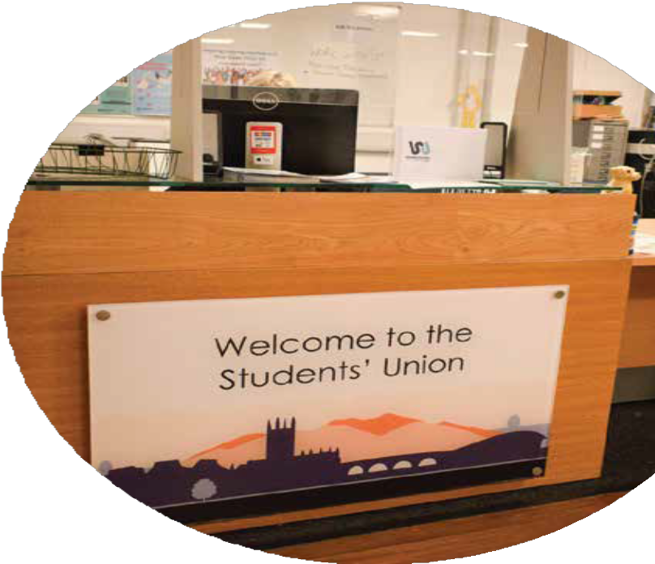
STUDENT DISCIPLINARY PROCEDURE
DISCIPLINARY PROCEDURES

All institutions which provide undergraduate courses must comply with consumer law. For more information on consumer rights see the CMA (Competition and Markets Authority) information for students.
Read the government Higher Education Guide to consumer rights for students:
A complaint of misconduct, either by one student against another or by a member of staff against a student, will be dealt with using the University's Student Disciplinary Procedure.
For information and

POSSIBLE OUTCOMES
Depending on the nature of the allegations there may be no further action. For more serious incidents students can be temporarily sus- pended from studies or permanently withdrawn.




The University procedure can be found here: https://www2.worc.ac.uk/registry- services/documents/StudentDis- ciplinaryProcedures.pdf
links, see the SU Advice
Service web pages:
www.worcsu.com/ helpandadvice/
academic/disciplinary/



PLACES TO GET ADVICE:
SU Advice Service
suadvice@worc.ac.uk
WHAT CAN THE SU DO?
Our Advisors Can:
- Help you understand the regulations and procedures to hopefully get the best outcome possible.
- Ensure that any case is handled in accordance with University procedures and that the outcome is reached fairly.
- Help you prepare for any meetings you might have to attend and accompany you if needed.
The University procedure can be found here: https://www2.worc.ac.uk/ registryservices/documen ts/FitnesstoPractise Procedures.pdf
links, see the SU Advice
Service web pages:
www.worcsu.com/help
andadvice/academic/
fitnesstopractice

FITNESS TO PRACTISE
Fitness to Practise procedures affect students studying on an academic course leading to a professional qualification. This includes teaching, nursing, and social work students.
The procedure covers students’ behaviour both in and out of University as well as on placement. An initial investigation will be undertaken if the University receives any information about the behaviour of a student which causes concerns regarding the student’s fitness to practise their profession.
This information could come from other students, colleagues, professionals, academics, or members of the public.

POSSIBLE OUTCOMES
Depending on the seriousness of the allegations there may be no further action, an action plan, or permanent withdrawal from your studies.
For information and

Academic integrity is an important part of study. The University has a process it puts in place if there is any suspicion of misconduct in assessments or exams. The term 'academic misconduct' is used to cover all the possible methods of plagiarism or 'cheating', both intentional and un-intentional.
ACADEMIC MISCONDUCT
As a student, you are expected to familiarise yourself with the different types of plagiarism and how to avoid it.
The penalties for academic misconduct can be very severe. Sometimes your degree classification can be downgraded or you might not be able to graduate with your course mates. We recommend getting advice as early on in the process as possible.
The University procedure and deadlines can be found here:

https://www2.worc.ac.uk/registryservic es/docu- ments/Procedures- forinvestigationofallegedacademicmisc onduct.pdf

PLACES TO GET ADVICE:

SU Advice Service | suadvice@worc.ac.uk
WHAT CAN THE SU DO FOR YOU?
OUR ADVIDSORS CAN:
Help you understand the regulations and procedures.
•
Registry | https://www2.worc.ac.uk/registr yservices/documents/Procedure sforinvestigationofallegedacade micmisc onduct.pdf




Ensure that any case is handled in accordance with University procedures and that the outcome is reached fairly.
•
Help you understand regulations and procedures.
•
Help you prepare for any meetings you might have to attend and accompany you if needed.
•
For information and
links, see the SU Advice
Service web pages:
www.worcsu.com/help
andadvice/academic/
fitnesstopractice

DEGREE CLASSIFICATIO N

Your degree is classified using one of two methods, this depends on when you commenced your studies.
The methods use either your credits at a certain grade or a grade point average.

THE OFFICE OF THE INDEPENDENT ADJUDICATOR (OIA)
The OIA operates an independent student complaints scheme for Higher Education.
If for any reason you are unhappy with how the University has investigated your complaint, you can take the matter to the OIA. However, you can only do this if you have exhausted the internal complaints procedure of the University.
To make a complaint to the OIA you must have first received a University Completion of Procedures Letter. Once this has been received there is a twelve month deadline to take a complaint to the OIA.

For more information about the OIA see: www.oiahe.org.uk



WHAT CAN THE SU DO?
book an appointment
The Advice Service can support any student in the process of making a complaint to the OIA

FROM YOUR
WWW.WORCSU.COM/HELPANDADVICE

