Improve your academic writing
A free, confidential service to help you
improve your writing skills
Students of any discipline, at any level of study (from 1st year to postgraduate) – and staff – are welcome to book a session.
The Royal Literary Fund Writing Fellow is a professional, published author whose role is to help you strengthen your writing.
Sign up for a one-to-one tutorial to help you:
- Plan your study time.
- Focus your reading for essay, dissertation or thesis writing.
- Express your ideas more clearly.
- Answer grammar and punctuation questions.
- Discover reading to improve your writing and editing skills.
- Increase your writing skills with the aim of improving your grades.
- Improve any academic writing – essays,reports, theses,dissertations, book chapters.
Sessions are for 50 minutes and take place online.
Please note that RLF Writing Fellows do not undertake proofreading or EAP tuition. To book a slot please email:
judith.allnatt@rlfeducation.org.uk (Monday and Tuesday)
sue.fletcher@rlfeducation.org.uk(Wednesday and Thursday)
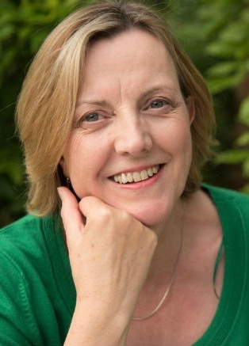
Judith Allnatt’s novels have been shortlisted for the Portico Prize for Literature and the East Midlands Book Award and selected by Radio 5 Live as ‘Book of the Month’. Short stories have featured on Radio 4 and in the Commonwealth Short Story Awards.

Sue Fletcher is a writer of both historical and contemporary fiction. Her first book, Eve Green, won the Whitbread First Novel award, the Betty Trask prize, and was shortlisted for the LA Times First Novel award. Her third, Witch Light, was shortlisted for the John Llewellyn Rhys prize. She is currently writing her eighth book.

