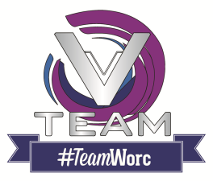
Provider Account Registration form
Thank you for getting in contact. Please complete all details in this form in order to have a provider account created on behalf of your organisation. Once registered, you will then be able to upload and advertise your opportunities directly to our website
Organisation Details
Name of Organisation
Charity number (if applicable)
Description/overview of organisation (max 600 characters)
Organisation Contact Methods
Telephone Number
Web Address
Postal Address
Postcode
Primary User Contact Information
Contact Name
Contact Email Address
Job Title
Additional Information
Do you cover volunteer expenses?
Do you perform DBS checks for volunteers?
Please return this form to SUVolunteering@worc.ac.uk – For any queries please call 01905 543210
We aim to have your organisation registered within 2 working days. You will receive a notification of your account creation, followed by your username and password. All details can be updated through your profile once signed in.

