To be read with the ‘Risk Assessment Guide’ which will set out how the form should be completed and the University and Students’ Union’s approach to risk assessment. If you have any questions, please seek advice from the Student Activities Manager or BUCS Sport Administrator (Sports Clubs) or the Student Groups Assistant or Student Communities Coordinator (Societies, Networks, Volunteering & Fundraising). Once completed, the control measures must be adhered to.

Note:

Brief description of the activity being assessed (include dates of event, and likely number of attendees)

Location: |  | Risk Assessor (name/committee position):
Student Group: |  | Date of Assessment:
Risk Assessment Reference & Version |  | Date of Review
Other people (s) commenting on this assessment (where required) | Name  Date |  | Approved by  Date
Process of communicating to relevant persons

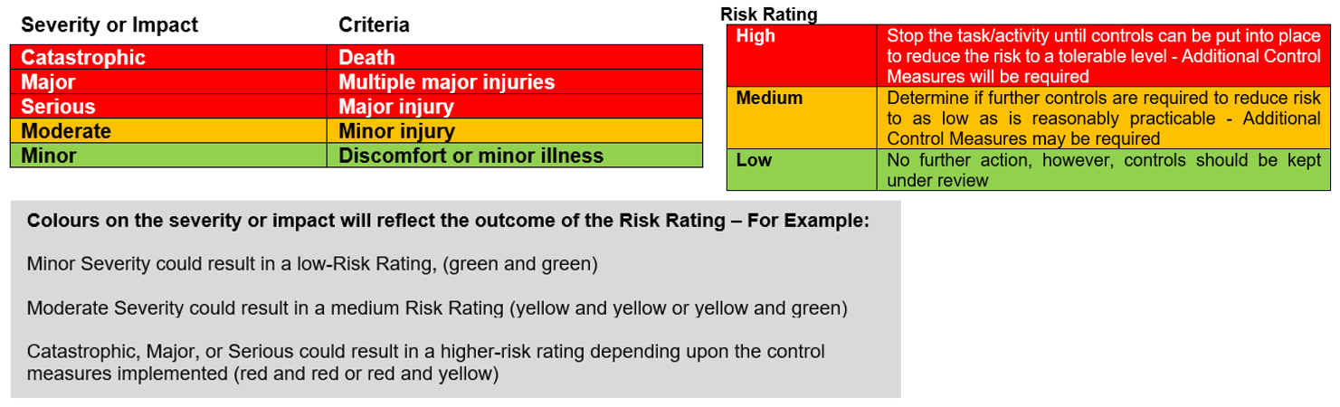

Hazards  (A hazard is something that can cause harm, e.g. electricity, chemicals, working up a ladder, noise, car, DSE) | People at Risk  (Students, Staff, Visitors, Contractors, Other) | What harm might occur,  (Slips Trips, Falls, Breaks, Sprains etc…) | Control Measures already in place  (Control measures include actions that can be taken to reduce the potential of exposure to the hazard). | Evaluate the Risk  (Having identified the hazards and controls, decide how likely it is that harm will occur), | Additional Control Measures  (Only necessary when additional controls are required.  These controls form part of the standard control measures when implemented.) | Revaluate the risk  By adding the additional controls, has the rating changed?

Action Ref | Action required | Who is responsible? | By when? | Date completed / Comments

