Risk Assessment Guide

What is risk assessment?
All you are being asked to do is to think about what can cause harm (a hazard) and to assess the potential for this to happen (risk). Having done this, you can identify the control measures necessary to perform the activity/event safely.
The idea isn’t to stop activities/events but to ensure that you’ve thought about ways to minimise any existing risks and thought about what you would do if an accident did happen.

Why should I follow a risk Assessment?
As a committee you hold a responsibility for ensuring the safety and wellbeing towards your participants/attendees. It is your legal responsibility to make sure your activities are as safe as possible. You must identify potential hazards to participants/attendees and put controls in place to reduce the likelihood of those hazards being realised to an acceptable level. This then gives you what is called the residual risk of the activity.

In the event of an incident, a risk assessment can be used to show that you did everything you could reasonably be expected to do to make your activity safe. If there is an accident you will, therefore, be asked to produce your risk assessment.

The Students’ Union insurance, also, requires that a risk assessment is completed before an event takes place or you will not be covered. For some more high-risk activities further insurance cover may be required. If you are not insured, then you are in danger of being personally sued if an accident does occur.

You can produce a generic risk assessment to cover your main activity, e.g. dance classes, practice sessions, drama productions or meetings, at the beginning of the year. Any groups using UW sport facilities will be expected to complete a risk assessment as part of their SLA (Service Level Agreement).

You will also need to produce specific risk assessments for any additional activities you organise or if you change your main activity, e.g. trips to different locations, practicing at a different venue, fundraising activities etc. They must be submitted with your Event Request form and Trip Request form, no later than 2 weeks before the event/activity is due to take place.

What about external venue/supplier and external events?
If you are taking part in an event or activity that is externally organised (e.g. outside your normal activity venue) you must check that they have appropriate risk assessments in place. If you are using an external provider/supplier as part of your activity e.g. catering, you should ask for a copy of their risk assessments.

It is your responsibility to ensure that all elements of your event are covered by risk assessments and you must be aware that even when using external companies you may still need to carry out your own risk assessment(s) e.g. for a trip to Alton Towers you will need to carry out a risk assessment for travel and group safety but your activity at the theme park will be covered by Alton Towers.

External risk assessments should be submitted alongside your event/trip request form and your own activity risk assessment(s).

Sharing the Risk Assessment
A risk assessment must be submitted for all events/activities/trips that your society/club offers. These will typically be sent alongside the Event or Trip Request Form.

Sports: Dan (daniel.cox@worc.ac.uk) or Sophie (sophie.smith2@worc.ac.uk)
Societies, Networks, Volunteering & Fundraising: Jack (jack.moore@worc.ac.uk) or Juwairiyyah (j.wali@worc.ac.uk)

If you have any problems or questions when completing your risk assessment or around external risk assessment(s) contact the above SU staff members who will be happy to help you.
If an accident or incident does occur, please remember that you must complete an incident/accident report form as soon as possible afterwards.

How to complete a Risk Assessment?

Five steps to completing the Risk Assessment

- What are the hazards?
- Who might be harmed?
- What are the current control methods?
- Evaluate the risk
- What additional control methods are required?
- Review the assessment and update when required.

Complete the first section of the risk assessment, providing details of the activity/event being assessed, location, date it is occurring and who has filled out the risk assessment.
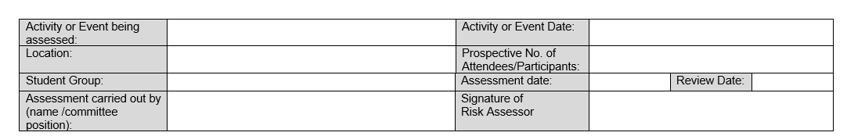

What are the hazards?
Use the hazard checklist (found in the Committee Resource Hub under Health and Safety), to help you to identify any of the potential hazards relating to your event/activity. You are not limited to the items on the checklist; a hazard is anything that might cause harm to participants. (E.g. food hygiene)

Who might be harmed and how?
Once you have identified what the hazards are you need to think about who may be harmed. This would typically include your members or students at the university, but may also include staff members, coaches, volunteers and external visitors. This will impact everyone not your just members.

Example 1:
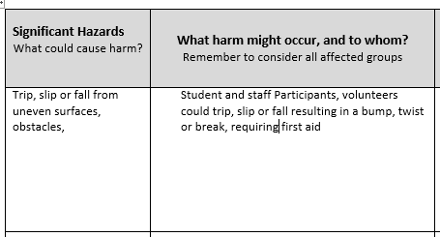

What are the current control methods?
Identifying the existing control measures should be simple, as you just state what is in place now. This could include wearing correct footwear, ensuring protective gear is worn, equipment checks or providing allergen information.

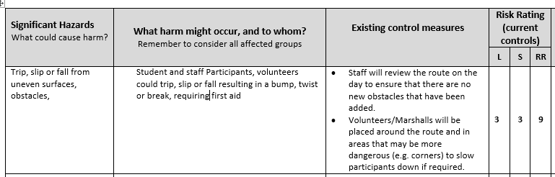
Example 2:

Evaluate the risk
When evaluating the risks you are only expected to anticipate foreseeable risks. You only need to consider things that might go wrong or become a problem in regular situations. Be realistic and consider what the likelihood of it happening is.
You must decide the likelihood and the severity of the hazard and multiply these two numbers together to get the initial risk rating.
- Likelihood- How likely the risk is to happen
- Severity – The Severity of the risk
- Risk Rating = Likelihood x Severity

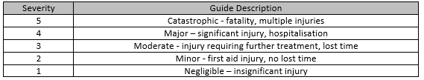
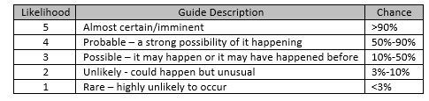
Consider the particular hazard and assess the risk by considering the likelihood of the worst-case scenario and the severity.

You multiply the likelihood sore by the severity score and that will give you your risk rating which will range between 1 and 25.

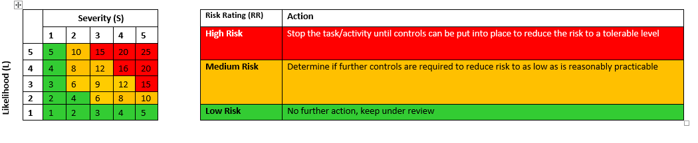
The following will give an indication of the rating and what you will need to do:
You will use these risk ratings to prioritise the higher risk activities for action.

Example 3:

What additional control methods are required?
If one of your identified hazards has an amber risk rating than the next steps is to look at implementing further controls. If the hazard has a red risk rating then you must identify additional control measures.

The next step is to state any control measures that you will implement to reduce the likelihood of risk and try and get the Risk Factor score down (example 3). You need to identify who is responsible for each control measure. You then record the effect of these changes into the Residual Risk section of the table. This is then the risk that will remain after the control measures are put in place.

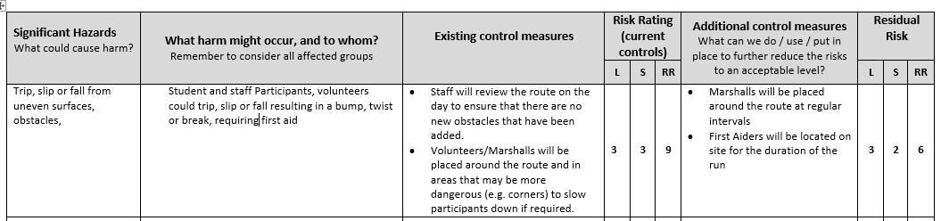
Example 4:

In example 4 this has lowered the risk level to medium risk that can be controlled and monitored. Some activities will always carry risk; it’s about minimising those risks as much as possible.

Example 5:
For those hazards that no additional control measures can be identified, the risk rating will remain the same.
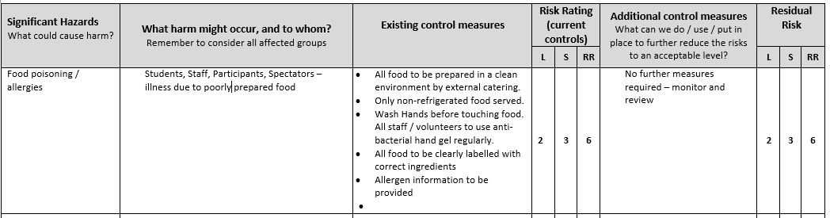

From your additional control measures you will create actions that need to be in place to prevent the hazard occurring. These are to be recorded in the “Action required” section of the template. Note what needs to be done, identify who will be doing this and when this should be completed by.

Review the assessment and update when required.
Don’t forget that if you have completed a risk assessment for a similar or exactly the same event/trip you can simply review your previous assessment, making sure that you are accounting for any changes and resubmit to the SU.

